2026-2027 Division of Career Pathways (DCP) Club Affiliates
In alphabetical order
Last updated: 9/15/2026
Digital version: career.uci.edu/resources-for-student-clubs/club-affiliates

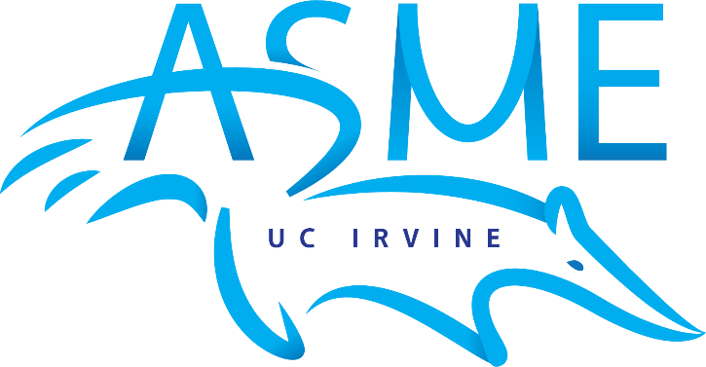

American Society of Mechanical Engineers at UCI
The American Society of Mechanical Engineers (ASME) at UCI is a nonprofit organization dedicated to supporting the engineering community by providing networking events, technical workshops, and opportunities for both professional and personal growth. We aim to connect students with industry professionals, foster hands-on engineering experiences, and build a strong, collaborative community on campus.
Email: asme@uci.edu
Website: asmeatuci.com
Instagram: @asmeatuci
LinkedIn: linkedin.com/company/asme-uci

Primary industry focus:
Manufacturing, Medical devices, Defense, Robotics, Aerospace, Automotives, Energy, Construction, HVAC, Research & Development, etc.
Job roles of interest:
Mechanical engineer, intern, or any other mechanical engineering focused jobs/ internships.

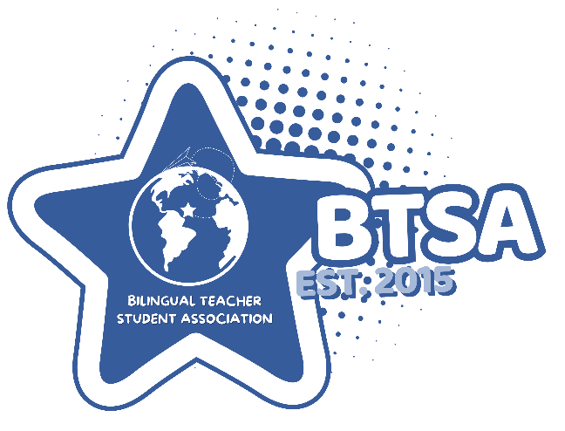

Bilingual Teacher Student Association at UCI (BTSA)
This organization’s mission is to develop and support future educators while promoting the importance of Bilingual Education. It also aims to create a space for those interested in learning more about Bilingual Education and connecting with fellow aspiring teachers.

We organize a variety of events guided by our four core pillars: Academics, Socials, Mentorship, and Volunteering:

Our Academic events include informational meetings / workshops. Socials bring our community together through engaging activities like Cultural Nights and Vision Board Making. Through our M&M Mentorship Program, we pair our members to provide personalized support. Finally, our volunteering allow members to give back to the community.
Email: btsaatuci@gmail.com
Website: zotspot.uci.edu/btsa
Instagram: @btsaatuci
Primary industry focus:
Employers throughout the education field, including public and private schools, school districts, dual-language and bilingual education programs, colleges and universities, tutoring and after-school programs, educational nonprofits, youth programs, and community organizations. We would especially value connections with local school districts and organizations that offer internships, employment, mentorship, or professional development opportunities for future educators.
Job roles of interest:
Teaching, bilingual and dual-language education, instructional aide and tutoring positions, after-school programs, coaching, counseling, mentoring, academic advising, school administration, educational outreach, and other student support roles. We are open to opportunities at the elementary, middle school, high school, college, and community levels.
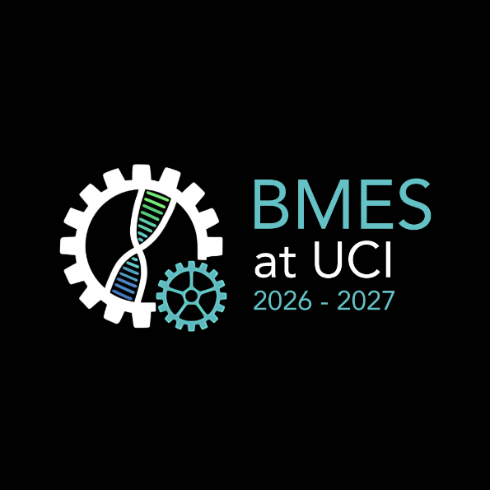

Biomedical Engineering Society at UCI
Our mission as the Biomedical Engineering Society at UC Irvine is to foster an inclusive community for students interested in biomedical engineering through mentorship, career building, project experience, and outreach opportunities for professional development and education.
Email: bmes@uci.edu
Website: bmesatucirvine.weebly.com
Instagram: @bmes_uci
TikTok: tiktok.com/@bmes.uci
LinkedIn: linkedin.com/company/bmesatucirvine
Primary industry focus:
We are targeting the biomedical industry which includes healthcare and biotech firms such as Johnson & Johnson, Medtronic, and Applied Medical to name a few big names.
Job roles of interest:
Positions in Research and Development, Manufacturing, Quality Assurance, Clinical, or any other engineering or consulting roles.

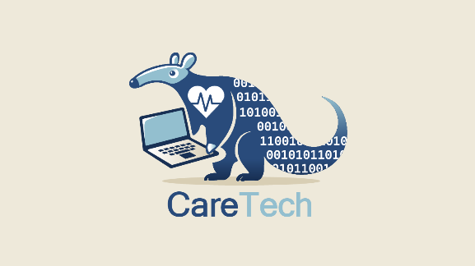

CareTech
Empowering Early Disease Detection with Innovative Tech Solutions.
Email: caretechirvine@gmail.com
Website: caretechuci.vercel.app
Instagram: @caretech_uci
LinkedIn: linkedin.com/company/caretech-uci
Primary industry focus:
Healthcare technology, digital health, biotechnology, pharmaceuticals, medical devices, and AI-driven healthcare. Examples include CVS Health, Kaiser Permanente, UnitedHealth Group (Optum), Epic Systems, Medtronic, Johnson & Johnson, GE HealthCare, Siemens Healthineers, Tempus AI, Abbott, and Illumina. We are also interested in connecting with broader technology employers that have strong AI and healthcare initiatives, such as Google, Microsoft, NVIDIA, Amazon (AWS), Apple as well as startups working in AI for healthcare and biomedical innovation.

Job roles of interest:
AI and healthcare technology roles, including AI/ML Engineer, Machine Learning Intern, Data Scientist, Healthcare Data Analyst, Software Engineer (Health Tech), Applied AI Research Intern, Clinical Informatics Analyst, Bioinformatics Engineer, AI Product Management Intern, and Data Engineering Intern. We are also interested in roles focused on digital health, medical imaging, predictive analytics, and healthcare software development.


Community of Diverse Empowerment in Computing
CODEC is dedicated to making technology accessible while fostering a supportive, confident, and inclusive community for students interested in this field. We strive to create an environment where every student, particularly those who are underrepresented, new to technology, or uncertain about their place in the industry, feels welcomed, valued, and empowered to grow.

Our mission is to assist students in finding their community, discovering their paths in the tech field, and developing the confidence necessary to thrive both academically and professionally. We believe that a sense of belonging is essential for success and that diversity, curiosity, and collaboration strengthen not only individuals but the entire tech community.

By providing a non-judgmental space where questions are encouraged and experiences are shared, we aim to alleviate feelings of isolation, intimidation, and inadequacy. The community and personal development fostered by CODEC will support students throughout their time at UCI and equip them for success beyond their academic journeys.
Email: codec.uci.corporate@gmail.com
Website: codec.ics.uci.edu
Instagram: @codec.uci
LinkedIn: linkedin.com/in/codec-uci
Primary industry focus:
Tech industries or additional companies with tech adjacent departments (healthcare, corporate, etc.)
Job roles of interest:
Careers in tech fields (e.g., software engineering, data science, etc.)

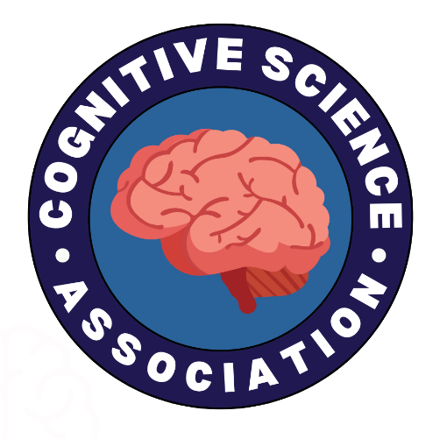

Cognitive Science Association
The Cognitive Science Association (CSA) at UC Irvine is a professional, academic, and social organization dedicated to students interested in the interdisciplinary field of cognitive science.

Our mission is to support and enrich the academic, personal, and career development of our members by providing practical resources and opportunities for exploration across the many paths cognitive science offers. We strive to build an inclusive and connected community of students who share a passion for understanding the mind and its many dimensions.
Email: cogsciassoc@gmail.com
Website: zotspot.uci.edu/cogsciassociation
Instagram: @csauci
LinkedIn: linkedin.com/company/cognitive-science-association-at-uci
Primary industry focus:
Artificial intelligence and technology, public health, neuroscience and biomedical research, healthcare, psychology and mental health services, business and consulting, education and educational technology, user interface (UI) and user experience (UX) design, linguistics, law and policy, philosophy, and other interdisciplinary fields.

Additionally research institutions, healthcare organizations, technology companies, startups, educational organizations, government agencies, and other employers seeking individuals with interdisciplinary backgrounds in cognition, behavior, and problem-solving.
Job roles of interest:
Summer research assistants, clinical research assistants, research coordinators, user research analysts, UX researchers, data scientists, data analysts, behavioral technicians, psychologists, psychiatrists, neuroscientists, linguists, software developers, machine learning and AI engineers, product managers, public health interns, human factors researchers, healthcare professionals, and other interdisciplinary roles related to cognitive science.



Cyber@UCI
Cyber@UCI is the premier applied cybersecurity resource on campus and is a community dedicated to making cybersecurity accessible to everyone, regardless of experience. Our mission is to help students become engaged in cybersecurity through hands-on workshops, competitions, and research. We provide a space for students and faculty to experiment and learn about cybersecurity however it pertains to their personal and/or professional interests.
Email: cyberclub@uci.edu
Website: cyberuci.com
Instagram: @cyberuci
LinkedIn: linkedin.com/company/cyber-uci
TikTok: @cyberuci
Discord: discord.cyberuci.com
Primary industry focus:
- Dedicated cybersecurity companies (e.g., CrowdStrike, Fortinet, Palo Alto Networks, Mandiant, SentinelOne, Trellix, Cloudflare, Okta, Snyk, Wiz)
- General tech companies with security teams (e.g., Google, Microsoft, AWS, Qualcomm, Intel, IBM, Meta, Apple)
- Security-specific start-ups (e.g., Armadin, Vanta, Chainguard, XBOW, Semgrep)
- Consulting organizations with security teams (e.g., Deloitte, PwC, EY)
- Local companies in need of security specialists (e.g., local government, small-medium businesses, consulting services)
- More specialized interests with security implications (e.g., healthcare, national labs)
Job roles of interest:
Cybersecurity, Security Engineering, Information Security, IT, DevOps, General Software Engineering roles such as: Security Engineer, Penetraton Tester, Red Team Operator, Threat Intelligence Analyst, Vulnerability Researcher, Product Security Engineer, Security Consultant, DevSecOps Engineer, Security Researcher, Systems Engineer, Network Engineer, Systems Administrator, Site Reliability Engineer, Technical Program Manager, GRC Analyst, Malware Analyst, Digital Forensics Analyst


Design at UCI
Design at UCI is the premier club for UI, UX, and graphic design that offers a community for all digital designers to connect, learn, and innovate. We provide a space for students to learn about design through various programs and opportunities such as Project Teams and Design-a-Thon.
Email: design@uci.edu
Website: designatuci.com
Instagram: @designatuci
LinkedIn: linkedin.com/company/design-at-uci
TikTok: tiktok.com/@design_at_uci

Primary industry focus:
Software & Internet, Google, Figma, Apple, Amazon, Microsoft, LinkedIn, Netflix, eBay, Meta, Adobe, Oracle, Nike.
Job roles of interest:
UI/UX Design, UX Research, Design Engineering, Graphic Design, Product Design, Product Management, Project Management, Frontend Developer/Engineer
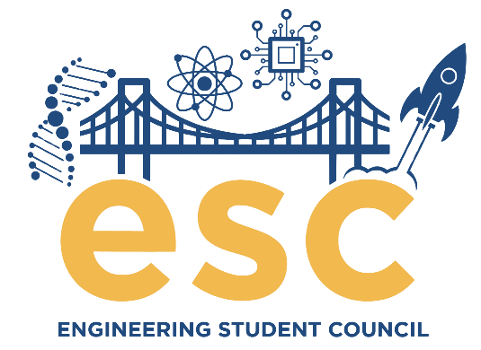

Engineering Student Council (ESC)
It is the mission of the Engineering Student Council (ESC) at UC Irvine to be a liaison between undergraduate engineering students and the faculty, staff, and administration of The Henry Samueli School of Engineering. ESC serves as the umbrella organization for other Engineering Student Organizations to promote cooperation and build relationships among students. We create networking and research opportunities for students by coordinating events with other organizations, faculty members, and corporations across Southern California. As student leaders, we envision and advocate for the educational, social, and professional advancement of the engineering community.
Email: esc.uci@gmail.com
Website: esc.eng.uci.edu
Instagram: @escatuci

Primary industry focus:
All Engineering industries, and especially those under-represented at UCI
Job roles of interest:
General Engineering related roles, as we represent engineers across all majors.
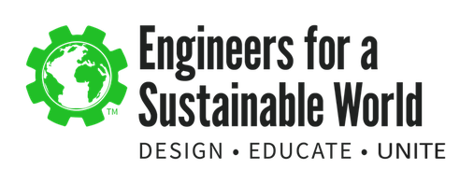
Engineers for a Sustainable World
Engineers for a Sustainable World at UCI is a student organization founded in 2016 to advocate for sustainability on campus by connecting students with the resources to learn more about the world and ways to develop technology to help engineer a better world.​
Email: esw.uci@gmail.com
Website: eswatuci.weebly.com
Instagram: @esw.uci
LinkedIn: linkedin.com/company/engineers-for-a-sustainable-world-uc-irvine
Primary industry focus:
Civil, Mechanical, Environmental, and Chemical industries.
Job roles of interest:
Any engineering positions that have sustainability involved or have a mission that builds towards a more sustainable future.


Eta Kappa Nu (IEEE-HKN)
IEEE-Eta Kappa Nu (IEEE-HKN), the national honor society of IEEE, is dedicated to encouraging and recognizing individual excellence in education and meritorious work, in professional practice, and in any of the areas within the IEEE-designated fields of interest.
Email: hkn@uci.edu
Website: hkn.eng.uci.edu
Instagram: @hknuci
LinkedIn: linkedin.com/in/ucihkn
Discord: discord.gg/aY5STVRKpc
Primary industry focus:
The entire field of Electrical Engineering and Computer Science (EECS).

Job roles of interest:
Electrical and Computer Engineering or Computer Science roles.
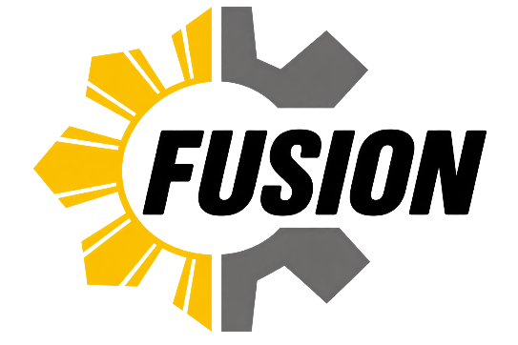

Filipinx Undergraduate Scientist-Engineers in an Organized Network (FUSION)
FUSION (Filipinx Undergraduate Scientist-Engineers in an Organized Network) exists to provide a community that fosters the personal and professional growth of members through the facets of the science & engineering field and Filipino culture.
Email: fusion.uci.networking@gmail.com
Website: fusionatuci.vercel.app
Instagram: @fusionatuci
LinkedIn: linkedin.com/in/fusionatuci
Primary industry focus:
Technology, software, engineering, aerospace, healthcare technology, consulting, finance/fintech, and consumer technology. We would be excited to connect with employers of all sizes, including established companies, startups, public-sector organizations, and mission-driven organizations that offer strong mentorship and early-career opportunities.
Job roles of interest:
Internship and entry-level roles across engineering and technology, including software engineering, electrical engineering, mechanical engineering, computer engineering, aerospace engineering, hardware design, systems engineering, data science, cybersecurity, and IT. We are also interested in adjacent roles such as product management, UX/UI design, technical program management, and business/data analytics.
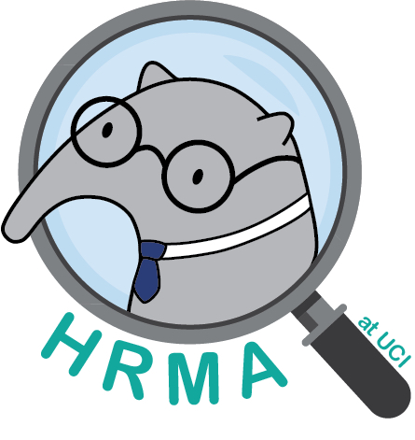
Human Resources Management Association at UCI
Our organization aims to educate young professionals on the nuances within the HR industry through guest speakers, mentorship and internship programs, professional workshops, and certification opportunities.
Email: hrma.uci@gmail.com
Website: hrmauci.com
Instagram: @hrmauci
LinkedIn: linkedin.com/company/hrmauci
Primary industry focus:
Big tech (Google, Meta, Amazon HR), entertainment/media, consulting/staffing firms, and healthcare.
Job roles of interest:
HR Intern, Recruiting Coordinator/Intern, Talent Acquisition Assistant, HR Assistant, People Operations Intern, Employee Engagement Intern, Learning & Development Intern, Compensation & Benefits Intern, and DEI Intern.
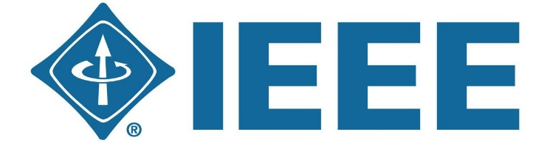

Institute of Electrical and Electronics Engineers (IEEE) at UCI
IEEE at UCI is a nonprofit engineering organization that empowers students through hands-on projects, technical workshops, and professional networking opportunities. We provide a collaborative community for students interested in electrical engineering, computer engineering, computer science, and related fields. Through programs like Open Project Space (OPS), Micromouse, and technical workshops, members gain practical skills, industry experience, and the confidence to tackle real-world engineering challenges.
Email: ieee.ucirvine@gmail.com
Website: ieee.ics.uci.edu
Instagram: @ieee_uci
Discord: discord.com/invite/s5D2trw
LinkedIn: linkedin.com/company/ieee-uci
Primary industry focus:
Electronics, software, robotics, telecommunications, semiconductor, renewable energy, aerospace and defense, manufacturing, and technology industries ranging from established industry leaders to innovative startups that are passionate about supporting the next generation of engineers.

We are especially interested in connecting with companies such as Northrop Grumman, Skyworks Solutions, MKS Instruments, Rohde & Schwarz, Broadcom, Qualcomm, NVIDIA, Intel, Texas Instruments, Anduril, Rivian, Amazon, Google, Microsoft, Apple, and other organizations that offer meaningful internship, career, and professional development opportunities for engineering students.
Job roles of interest:
Internship and full-time opportunities across electrical engineering, computer engineering, computer science, and related disciplines. Roles of particular interest include hardware, embedded systems, firmware, software engineering, electrical engineering, RF engineering, robotics, semiconductor, systems engineering, cybersecurity, data science, AI/ML, product engineering, and other technical positions. We also welcome opportunities in project management, technical consulting, manufacturing, and engineering leadership that support students with diverse career interests and backgrounds.
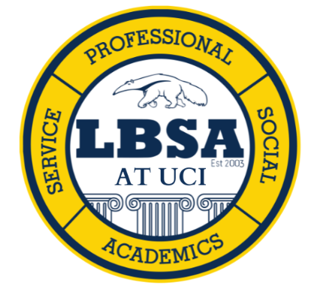

Latino Business Student Association
The Latino Business Student Association is a student-run non-profit organization established in 2003. The purpose of LBSA is to assist its members, from various ethnic backgrounds and fields of studies at the University of California, Irvine in pursuing professional skills and careers while raising awareness of the Latino culture. The organization accomplishes this by focusing on its three pillars: Professional Development, Social Interaction, and Community Service, with the foundation of Academic Achievement.
Email: internalvp.lbsauci@gmail.com
Website: lbsauci.org
Instagram: @lbsauci
TikTok: tiktok.com/@lbsauci
LinkedIn: linkedin.com/company/lbsauci
Primary industry focus:
Entertainment companies like FOX, Warner Bros., and Disney, and consulting companies. We are also interested in connecting with accounting companies, such as EY, PwC, KPMG, and Deloitte.

Job roles of interest:
Roles and internships in finance, accounting, operations, and marketing.
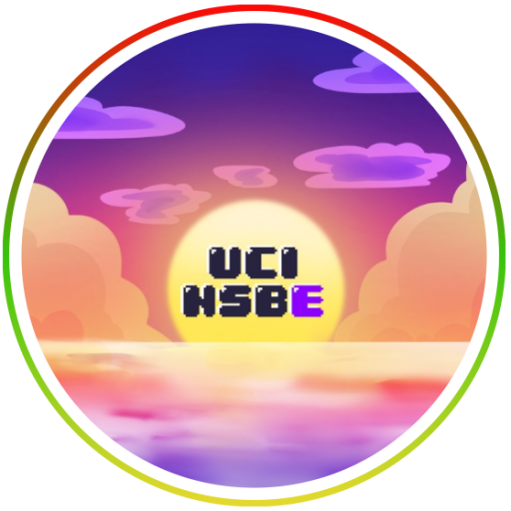

National Society of Black Engineers
The National Society of Black Engineers (NSBE) is a professional organization dedicated to supporting the academic, professional, and personal development of Black students in engineering and other STEM fields. Through networking events, career workshops, conferences, mentorship, and community service, NSBE helps members build valuable skills and connect with industry professionals. The organization also creates a supportive community that encourages students to succeed academically, develop as leaders, and pursue meaningful careers in STEM.
Email: ucirvinensbe@gmail.com
Website: sites.uci.edu/nsbeatuci
Instagram: @nsbeuci
LinkedIn: linkedin.com/company/ucirvine-nsbe
Primary industry focus:
Our club is interested in connecting with employers across the technology, aerospace, energy, healthcare, biotechnology, manufacturing, construction, automotive, and environmental sectors. We are especially interested in companies, government agencies, research institutions, and engineering firms that offer internships and entry-level positions. Potential employers include organizations such as NASA, Boeing, Northrop Grumman, Jacobs, Southern California Edison, Google, Microsoft, Johnson & Johnson, Abbott, SpaceX, and local engineering firms.
Job roles of interest:
Entry-level opportunities across engineering and other related STEM fields. Areas of interest include mechanical, electrical, chemical, civil, biomedical, environmental, and software engineering; computer science; data science and analytics; cybersecurity; product management; research and development; project & product management; manufacturing; and quality assurance.

Pilipinx-Americans in Social Studies (PASS) at UCI
Pilipinx-Americans in Social Studies (PASS) is an organization that focuses on fields relating to business, law, humanities, social sciences, and social ecology. PASS is a “community within a community” striving to increase the representation of Pilipinxs and other minorities within professional industries while providing a social support network that promotes academic excellence, career development, community involvement, and leadership opportunities for students in the UCI (University of California, Irvine) and Pilipinx communities.
Email: pass.career@gmail.com
Website: passatuci.weebly.com
Instagram: @passatuci
TikTok: https://www.tiktok.com/@passatuci2
LinkedIn: linkedin.com/groups/13914820
Primary industry focus:
Social sciences, business, law, social ecology, arts, and humanities.
Job roles of interest:
Lawyer, paralegal, law assistant, forensic analyst, accountant, financial analyst, business management, real estate agent, property management, basic needs coordinator, child social worker, non-profit organization management, child psychologist, school psychologist, school counselor, higher education professor, community college professor, data scientist, data analyst, business intelligence analyst, film industry logistics, DEI entertainment coordinator, film production, program management, community coordinator, journalism.

Undergraduate Public Health Association
Public Health Association at UC Irvine is an organization dedicated to promoting public health through education, service, advocacy, and social engagement. Open to students of all majors at UC Irvine, PHA gives members the chance to explore careers and current issues in the field of public health, serve the UCI campus and greater community through student-led and partnered activities, and network with diverse individuals who aspire to improve public health in their communities and across the globe.
Email: phauci@gmail.com
Website: phauci.wixsite.com/phauci
Instagram: @phauci
LinkedIn: linkedin.com/in/public-health-association-at-uci-031b5b354
Primary industry focus:
PHA is interested in establishing relationships with employers and institutions that prioritize public health. These can include larger organizations like the Centers for Disease Control and Prevention (CDC), Substance Abuse and Mental Health Services Administration (SAMHSA), and California Department of Public Health (CDPH), as well as local hospitals, health clinics, and prevention programs. We would also like to establish connections with industry experts who regularly work on public health concerns, such as epidemiologists, environmental health scientists, safety managers, healthcare administrators, and community health advocates.
Job roles of interest:
Full- or part-time jobs and internships in the field of public health including those that require a bachelor's degree as well as those that call for a higher education (Master’s or PhD). These positions can include working as an epidemiologist, health analyst, clinical research manager, health educator, community planner, and health informatics manager.

Pre-Law Latinx Association
The mission of PLLA is to increase Latinx representation in the legal profession by supporting students on their path to law school and other postgraduate opportunities. Because Latinx individuals remain underrepresented in the legal field, we are committed to empowering the next generation of legal professionals through access, guidance, and community.
Our goal is to foster an inclusive and supportive network for students interested in pursuing a pre-law pathway. We achieve this by providing LSAT and law school preparation, mentorship opportunities, professional skill development, and educational workshops featuring legal professionals and guest speakers. Through these resources, PLLA aims to equip aspiring law students with the knowledge, confidence, and connections needed to succeed in law school and beyond.
Email: plla.ucirvine@gmail.com
Website: zotspot.uci.edu/plla
Instagram: @plla.uci
LinkedIn: linkedin.com/company/pre-law-latinx-association-at-uci
Primary industry focus:
Law firms (small, mid-sized, and large firms), Corporate legal departments, Federal, state, and local government agencies, District Attorney, Public Defender, and City Attorney offices, State and federal courts, judicial chambers, and clerkship programs, Legal aid organizations and public interest law firms, Civil rights, immigration, and social justice organizations, Nonprofit organizations focused on advocacy and public policy, Legislative offices and government affairs organizations, Compliance, regulatory, and risk management departments, Consulting firms with legal, public policy, or regulatory practices, Law schools and legal education organizations, Professional legal associations, including bar associations and affinity organizations

Job roles of interest:
- Legal internships (law firms, legal aid organizations, district attorneys' offices, public defenders' offices, corporate legal departments, and government agencies)
- Judicial internships and externships
- Paralegal, legal assistant, and case management roles
- Public policy, legislative, and government affairs internships
- Compliance, risk management, and regulatory affairs positions
- Human resources and employee relations roles
- Nonprofit advocacy and community outreach internships
- Research assistant positions related to law, policy, and social justice
- Undergraduate research and fellowship opportunities
- Leadership development, mentorship, and professional networking programs

Pre-Law Society
Pre-Law Society at UCI is dedicated to assisting UC Irvine undergraduates who are looking to pursue a career in law or legal studies. Our organization strives to provide UC Irvine undergraduates with tools needed to be successful in law schools such as opportunities to see lawyers on the job, create connections, develop leadership skills and more hands-on experiences in the field of law. Pre-Law Society hosts diverse programs (e.g., LSAT informational seminars, law school admissions panel, as well as speaker panels) to help UCI undergraduates reach an informed decision about their career. We help students with outreach into internships, and job opportunities in the area though our weekly newsletter.
Email: prelawsocietyuci@gmail.com
Website: prelawsocietyatuci.weebly.com
Instagram: @prelawsocietyuci
LinkedIn: linkedin.com/company/pre-law-society-at-uci
Primary industry focus:
Law firms, solo practicing lawyers/attorneys, law schools that have jobs available in the law school, and government establishments that have administrative positions for undergrads. (ie. UCI School of Law, American Bar Association Undergraduate Internship, Andal Law Group).
Job roles of interest:
Internships in law firms, government establishments, or at law schools. We are also interested in part-time positions that accept undergraduate applicants, and can help with the development of our members.
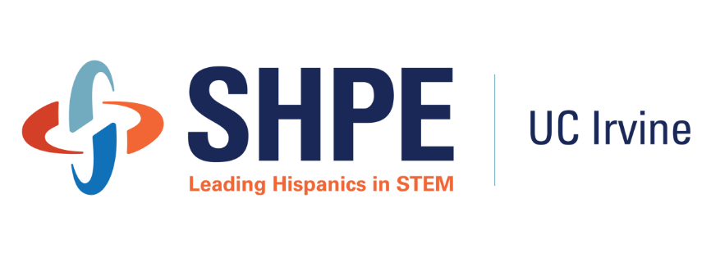
Society of Hispanic Professional Engineers (SHPE)
SHPE at UCI is dedicated to empowering Hispanic and underrepresented students in STEM to achieve their academic, professional, and personal goals. Through professional development workshops, networking opportunities, industry partnerships, mentorship, and community-building events, we provide members with resources and support to prepare for internships, full-time careers, and continued professional growth. Our organization strives to build a strong and inclusive community of future engineers and STEM professionals while connecting students with opportunities to develop their skills, expand their networks, and succeed beyond UCI.
Email: shpe.uci@gmail.com
Website: shpe.eng.uci.edu
Instagram: @shpe_uci
LinkedIn: linkedin.com/company/shpeatuci
Primary industry focus:
We are especially interested in connecting with employers in construction, infrastructure, transportation, aerospace, manufacturing, energy, utilities, medical devices, technology, consulting, and other engineering-focused industries. We are also open to employers across the broader STEM field that offer internships, entry-level positions, mentorship, and professional development opportunities for undergraduate students.
Job roles of interest:
Mechanical engineering, civil engineering, structural engineering, construction/project engineering, manufacturing engineering, design engineering, quality engineering, test engineering, research and development, and project management roles. We are also interested in internship and early-career opportunities across all engineering and STEM disciplines, including biomedical, electrical, computer, environmental, chemical, aerospace, software, data science, and other technical fields.
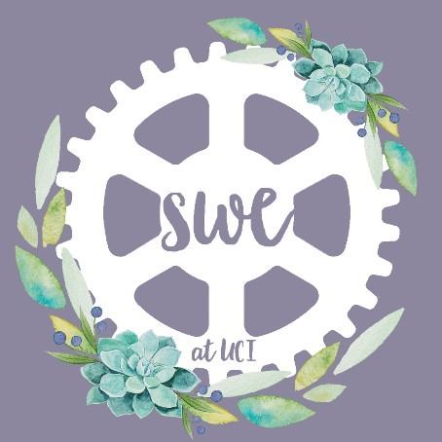
Society of Women Engineers
The Society of Women Engineers (SWE) is a not-for-profit educational and service organization that empowers women to succeed and advance in the field of engineering, and to be recognized for their life-changing contributions as engineers and leaders. Founded in 1950, SWE is the driving force that establishes engineering as a highly desirable career for women through an exciting array of training and development programs, networking opportunities, scholarships, outreach and advocacy activities.
Email: swe.uci@gmail.com
Website: sites.uci.edu/societywomenengineers
Instagram: @swe.uci
LinkedIn: linkedin.com/company/society-of-women-engineer-uc-irvine
Primary industry focus:
Engineering, including chemical, materials, mechanical, aerospace, civil, and biomedical engineering.
Job roles of interest:
Entry-level jobs and internships within engineering, such as R&D, Quality, Manufacturing, and more.

Tau Beta Pi Engineering Honor Society
The Tau Beta Pi Honor Society is the oldest engineering honor society and the second oldest collegiate honor society in the United States. It honors engineering students who have shown a history of academic achievement as well as a commitment to personal and professional integrity. Our chapter, California Tau, focuses on developing well-rounded skills, preparing members for their careers, and giving back to the community. Our goal is to support our members in their continued pursuits of integrity and excellence.
Email: tbp-ca@uci.edu
Website: tbp.eng.uci.edu
Instagram: @tbpuci
Primary industry focus:
Any field of engineering and tech.
Job roles of interest:
Engineering and engineering-related roles.

Video Game Development Club
VGDC is a student-led, game development club at UC Irvine, dedicated to supporting and teaching students how to make games! VGDC is open to everyone!
Email: vgdc@uci.edu
Website: vgdc-uci.com
Instagram: @vgdc.uci
Discord: discord.com/invite/n8wuWnkXVC
LinkedIn: linkedin.com/company/video-game-development-club-at-uci
Primary industry focus:
Game Development Industry. Companies such as Blizzard, Riot Games, Turtle Rock Studios, Mobilityware.
Job roles of interest:
Gameplay Programmer, AI Programmer, Tools Programmers UI/UX Designers, Product Designer, Game Designer, QA Tester, Audio Engineer, Technical Artist, Concept Artists, 3D Artist, Producer, Project Manager.

Women in Information and Computer Science (WICS)
Women in Information and Computer Sciences (WICS) is a social and professional organization at UCI established to help and encourage women to pursue a college degree and a successful career in the tech field.
Email: wics@uci.edu
Website: wics.ics.uci.edu
Instagram: @wicsuci
LinkedIn: linkedin.com/company/wics-uci
Primary industry focus:
Software engineering, AI/ML, cybersecurity, data science, cloud computing, IT, FinTech, bioinformatics, gaming, consulting, and startups.

Employers such as Google, Microsoft, Amazon, Apple, Meta, NVIDIA, Qualcomm, Netflix, Broadcom, Blizzard Entertainment, Riot Games, Boeing, SpaceX, Edwards Lifesciences, Medtronic, First American, Capital Group, Deloitte, Accenture, PwC, EY, Cisco, Oracle, Adobe, Salesforce, ServiceNow, and local Orange County and Southern California startups
Job roles of interest:
Software Engineering, AI/ML, UI/UX, Data Science, Project Management, Product Management, Technical Program Management, Cybersecurity, Game Design
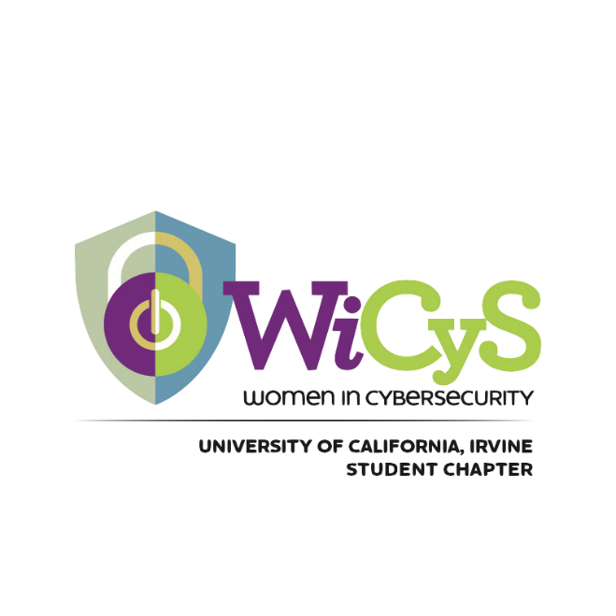
Women in CyberSecurity Student Chapter at UCI - WiCyS
WiCyS at UCI is a student chapter of the national Women in Cybersecurity organization, dedicated to building a supportive community for students interested in cybersecurity. We host workshops, speaker events, and career-prep sessions to help members develop technical skills, explore career paths, and connect with professionals in both the research and corporate field. Our goal is to empower and increase the representation of women and other underrepresented groups in cybersecurity.
Email: wicys@uci.edu
Website: sites.uci.edu/wicys
Instagram: @wicysuci
LinkedIn: linkedin.com/company/wicys-uci
Primary industry focus:
Big Tech: Google, Amazon, Nvidia, Apple, Microsoft, IBM
Cybersecurity: Crowdstrike, Palo Alto Networks
Federal Agencies: CISA, NSA, DoD

Also, local startups/companies not restricted to the tech industry (ex. First American, Cotality). We would like to give our members the options of cybersecurity related companies and the tech industry in general.
Job roles of interest:
Cybersecurity professionals, Cloud Security Engineer, Cybersecurity Researcher, Risk & Compliance Analyst, Quality Assurance, Software Engineer, Data Science, Data Analytics.

Women in Leadership
Women in Leadership (WIL) is a student organization with a mission to bring together a community of undergraduate students interested in exploring the opportunities and potential of women in leadership and business. Open to all majors and backgrounds, our club provides speaking panels, professional and personal development workshops, networking mixers, and a mentorship program. We believe in empowering women to believe in themselves and to set goals aligned with their dreams.
Email: womenuci@gmail.com
Website: womenuci.weebly.com
Instagram: @womenuci
LinkedIn: linkedin.com/company/womenuci
Primary industry focus:
A variety of industries spanning business, finance, consulting, human resources, accounting, beauty, technology, engineering, healthcare, and entrepreneurship.
Job roles of interest:
Entry-level jobs/internships and rotational programs, leadership development programs, internships, and career opportunities that help our members expand their skills, grow as leaders, and prepare for successful careers across diverse industries.

Zotckets
Zotckets is a student-led organization dedicated to encouraging students to explore engineering through hands-on experience in rocketry. Our goal is to help students design, manufacture, and launch their own L1 rockets, enabling them to receive certification. Through club-facilitated workshops and events, we aim to create a community where students can engage in a meaningful project alongside their peers, enhance their resumes, and pursue their professional or personal goals. Anyone is welcome to join the club, regardless of experience or major, as we aim to create a community that caters to students from diverse backgrounds. In the long term, we plan to expand our organization into an interdisciplinary club that fosters innovation in rocketry across various STEM fields.
Email: zotckets@uci.edu
Website: zotckets2.wixsite.com/zotckets
Instagram: @zotcketsatuci
LinkedIn: linkedin.com/company/zotckets
Primary industry focus:
Aerospace and space exploration industries. Examples include, but are not limited to, VAST Space, Anduril, SpaceX, Rocket Lab, Parker Hannifin, Northrop Grumman, Boeing, and Blue Origin.
Job roles of interest:
Mechanical and aerospace engineering jobs/internships roles.

